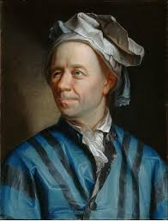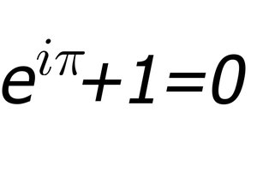

Leonhard Euler
07.09.2017
─
Tadhg

Overview
This is a project on the life of Leonhard Euler the gifted mathematician, physicist and astronomer

Specifications
This project is divided into 4 different sections

1.Early life of Eular

2. Contribution to mathematics and awards obtained

3. The effects of Euler's contributions on the future mathematics and society

4. Euler's later life

1. Early life
Leonhard Euler was born on 15 April 1707, in Basel, Switzerland. His father, Paul III Euler, was a Calvinist pastor and his mother, Marguerite née Brucker, was a pastor’s daughter. Euler had two younger sisters: Maria Magdalena and Anna Maria, and a younger brother: Johann Heinrich. When Euler was one year old, the family moved from Basel to the town of Riehen, which is about 7 km from Basel.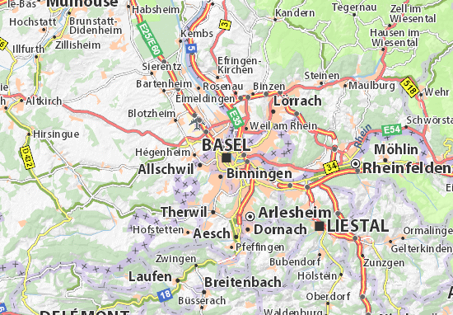
Euler’s school was a poor one, so he got extra maths lessons from his father. When he was 13, in 1720, he enrolled at the University of Basel and graduated 3 years later with a Master of Philosophy, at the age of 16
.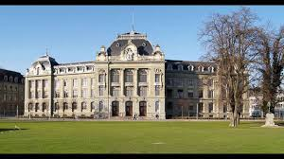
His father wanted him to become Calvinist pastor, but Euler’s father was friends with Johann Bernoulli, who was considered Europe’s foremost mathematician at that time, and Bernoulli convinced Euler’s father that Euler was gifted in mathematics and so Euler was allowed to spend three more years studying under Bernoulli.
In November 1726, Euler was offered a place in the physiology division in the Imperial Russian Academy of Sciences in Saint Petersburg, as a result of a recommendation from Johann Bernoulli’s son Daniel, who was working there. Euler delayed making the trip as he unsuccessfully applied for a professorship at the University of Basel. In May 1727, Euler arrived in Saint Petersburg. He was later promoted from his position in the physiology department to the mathematics department. Most of the scientists in the Academy were foreign, so the Russian nobility were suspicious of them and they cut the funding for the Academy and caused other difficulties for Euler and his colleagues. In 1731 Euler was made a professor of physics. Two years later, Daniel Bernoulli left for Basel as he was fed up with the hostility he faced in Saint Petersburg and Euler succeeded him as the head of mathematics.In January 1734, Euler married Katharina Gsell. Only five of their thirteen children survived childhood.

2. Contributions to Mathematics and Society
Leonhard Euler has made many contributions to many areas in mathematics. His largest contributions have been in calculus, the introduction of many notations used today such as e,π,Σ and i and much more.
One of eulers most famous contributions was the introduction of e into calculus. He discovered the constant e. He made this discovery by solving a problem encountered by Jacob Bernoulli in the 17th century. Bernoulli’s problem was about compound interest.
It goes like this. Presume you had €1 and you were offered 100% interest on that money over the space of a year. At the end of the year you would have €2.
Now imagine you were offered 50% interest every six months. After six months you would gain 50c of interest leaving you with €1.50. After another six months you would receive 50% interest on this €1.50 leaving you with €2.25. So clearly it is more worthwhile for the investor to receive interest more often.
Bernoulli even came up with a formula to calculate compound interest you'd receive in a year
(1+1/n)^n. Where n is the number of times you receive interest that year. Bernoulli didn't solve this, instead Euler did.
Euler found this was an irrational number and discovered it with the formula 1+1/1!+½!+⅓!+¼!.... this sequence goes on forever and gives the irrational number 2.718281828…..
e is very useful in calculus. The exponential function e^x has the gradient e^x and the area under the curve is equal to e^x. It is the only function to have this property.
For example consider the function e^x where x=3. The gradient at the point of the graph e^3 is e^3 and the area under the graph from the point e^3 all the way back to negative infinity is e^3
This allows mathematicians to write functions in terms of e which makes the mathematics a lot easier in calculus.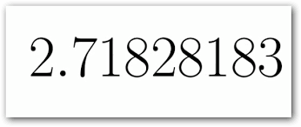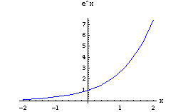

3. The effects of Euler's contributions on the future mathematics and society
As you saw above Eular contributed his life to mathematics and while his work didn’t create atomic bombs or help end a war but his contributions still had a large effect.
His mathematical notation is still used today with the use of e is still called Euler’s number today. His invention of i as the imaginary number. He was also used f(x) to describe a function which previously had never been done before. He is also the only mathematician to have two numbers named after him e (Euler’s number) and Y (gamma) otherwise known as Euler’s constant and it’s value is approximately 0.5772156649.
He was also regarded for his calculus work as his formula released in 1748 was voted most beautiful formula in 1990 showing that nearly two hundred and fifty years it still is a work of art showing that this beauty is timeless.
Euler wrote over 500 books and papers in his lifetime (about 800 pages a year!). Don’t worry I won’t list them all because that is a waste of both our time also I don’t speak russian or latin which is what he wrote most of his papers in!
Euler was also featured on the swiss 10 franc not. The 2002 Euler asteroid was named after him.
Though he is not a household name he is well known by mathematicians, physicians and astronomists for his importance his genius and for his formula.

4. Later life
Eular returned to St. Petersburg Academy from an invitation from Catherine the Great in 1766. He was fifty nine at the He did this on certain conditions they were a 3000 ruble salary, a pension for his wife and high ranking positions for his sons. These conditions were met so he moved into a Russia where he spent his remaining life.
After almost thirty years of being almost blind in his right eye he developed a cataract in his left eye. In a few weeks he became blind though it did not seem to affect him as his mind made up for his disability. He saw his disadvantage as his advantage saying “now I will have fewer distractions”. This was the year that he published twenty seven papers.
Tragedy struck Eular as a fire burned down his home and library in the great fire of St.Petersburg of 1771 and was carried out by his servant Peter Grimm. He soon after regained his sight but after the operation did not give his eyes proper care and thus lost his sight again. Eular lost his wife when she was 66 in the year 1773 after 40 years of marriage. These terrible years of loss did not stop him though he continued to work. He later married his wife’s half sister Salome Abigail Gsell.
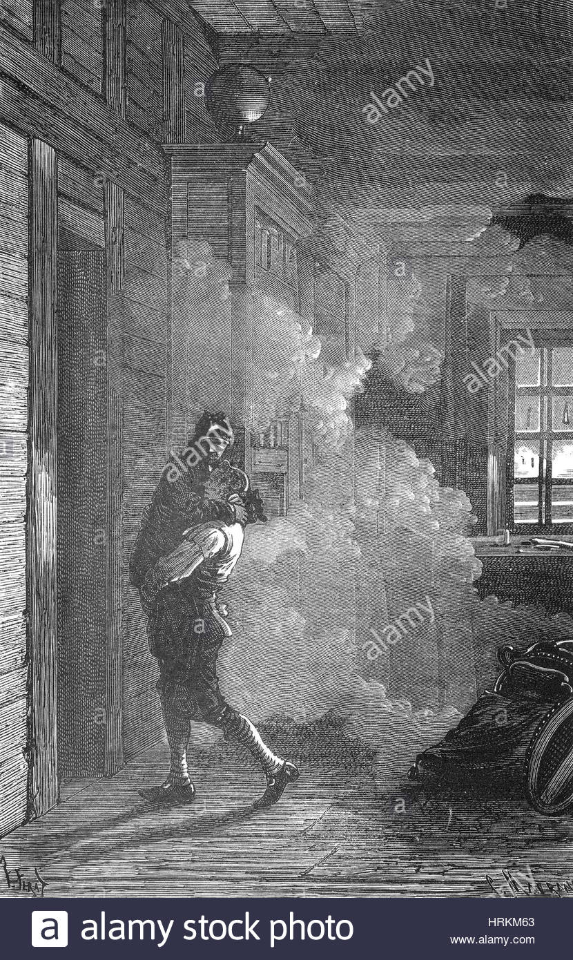
When he was having a discussion with Anders Johan Lexell on the newly discovered planet uranus after a meal with his family. He collapsed of a brain hemorrhage and died a few hours later.
Eular lived a long life for his time living to be 76 when the average life expectancy was under 40. He was buried next to his wife in Smolensk Lutheran Cemetery in St.Petersburg but his remains were later moved to Alexander Nevsky Monastery along with his remains in 1956.
